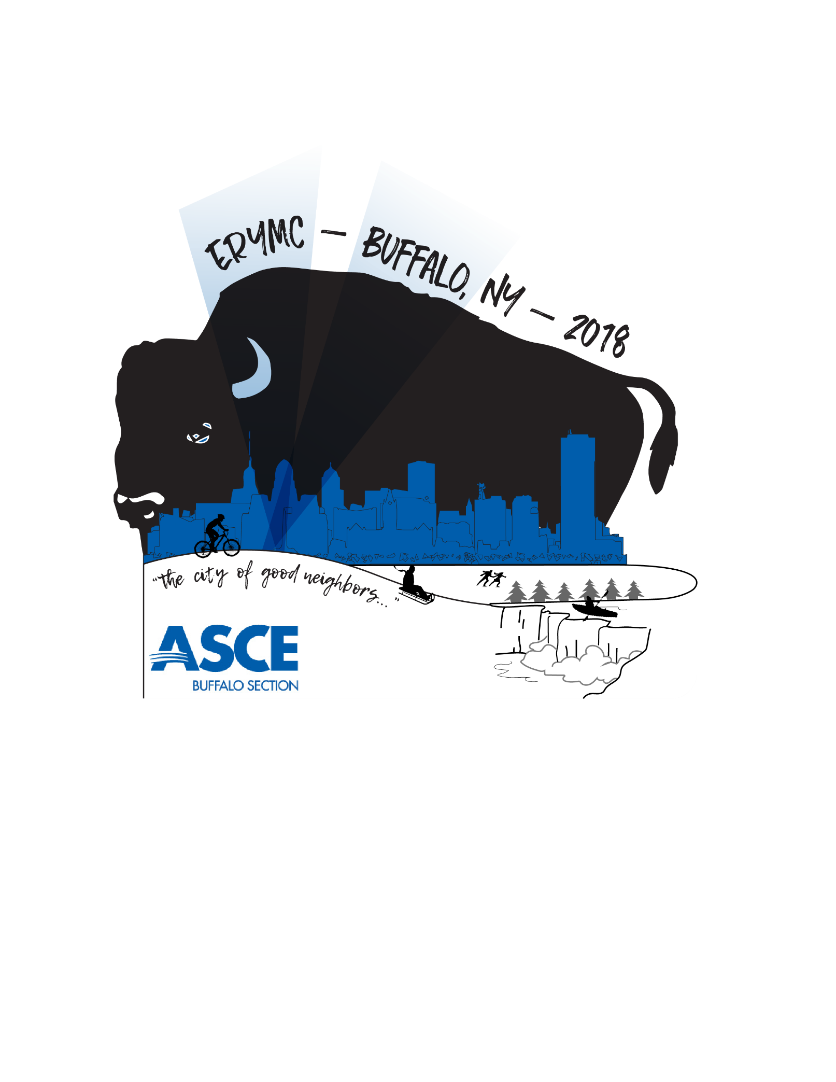

Hyatt Regency Buffalo

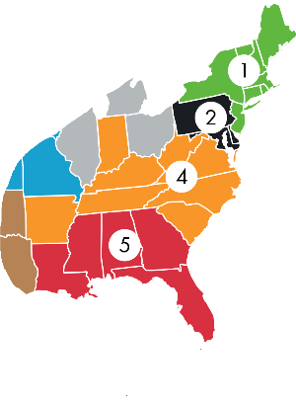Regions 1, 2, 4, & 5

**Hot Sponsors**

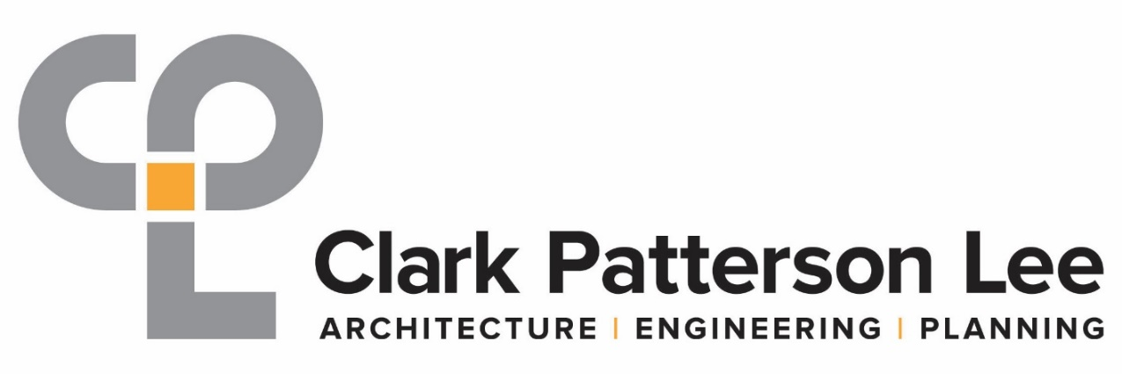





**Hot Sponsors**

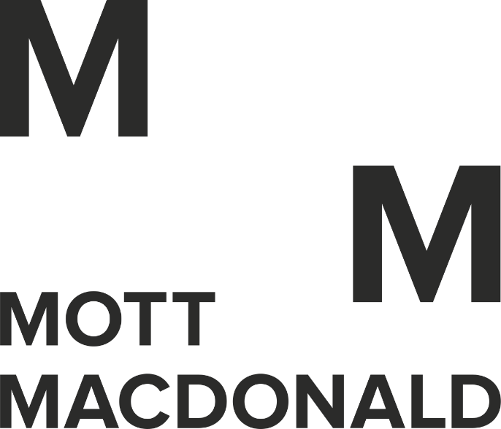





**Medium Sponsors**



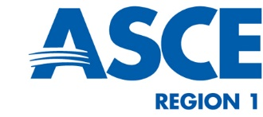



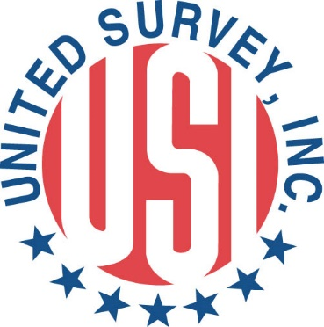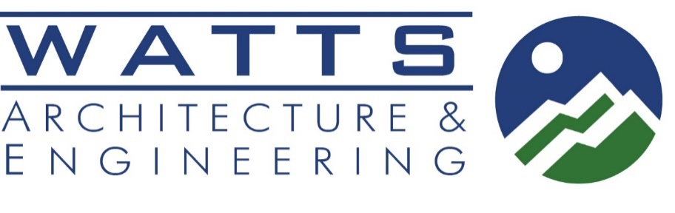

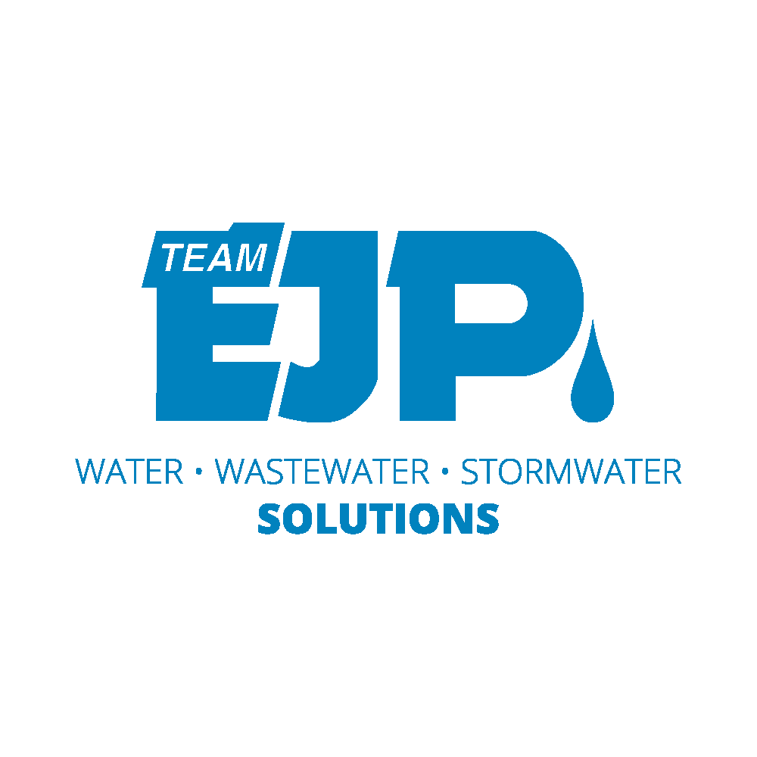**Mild Sponsors**

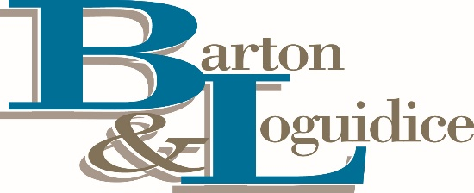



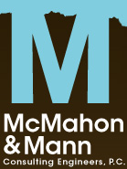

SPECIAL THANKS TO:

****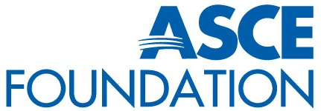

Melanie Anderson – Logo Design

Tim Van Oss – Registration

Jeremy Desjardins - Webmaster

Table of Contents

Welcome Letter8

Maps & directions4

Hotel information5

Hotel floor plans5

Transportation5

Public/nfta rail map6

Shuttles, vans, & taxis6

Rental Cars6

Ride sharing6

Emergency Contact Information4

Agenda4

special Events4

Thursday & Friday5

SATURDAY5

ASCE Bios4

Speaker Bios4

Buffalo recommendations4

Welcome to Buffalo!

On behalf of the 2018 Eastern Region Younger Member Council (ERYMC) Planning Committee and ASCE Buffalo Section, welcome to the Queen City, the “City of Good Neighbors” and more notably “the City of Light”. The numerous names come from our bountiful history, architecture, and proud community; which we encourage you explore over the next few days.

**First timers!** – Get ready for a memorable weekend. Explore with others, meet new friends, network with your ASCE counterparts, try something new (like curling), learn new skills and strategies, and meet a variety of engaged and diverse individuals. There are over **400** attendees! We are all here for the same objectives, to improve a variety of skill sets including: engineering knowledge, leadership, networking and professional development. Critical components to our careers that will ultimately lead to projects and interactions that improve the lives of so many. So get out there and talk to any of the following: ASCE National leadership, local volunteers and professionals, Regional Governors, section and branch leaders, student members, and younger members. We have amazing stories and a wealth of advice and experience to share. Most importantly, bring the energy, excitement, knowledge and diversity from this conference back to your section or branch and implement what you’ve learned.

**Veteran Attendees** – there is always more to learn and we believe this schedule will give you a taste of new things you haven’t experienced yet, both edible and otherwise. And just like the first timers…bring the energy, excitement, knowledge and diversity back to your section or branch!

**News:**

Skating and curling will be happening at [Canalside](https://www.canalsidebuffalo.com/)! So don’t forget to sign up on the [website](http://ascebuffalo.org/register), which will also have all the other conference information.

*We have a conference App! Available February 5th for both Android and Apple called “ERYMC 2018”.



**Reminders:**

* [Weather](https://weather.com/weather/tenday/l/USNY0181:1:US) – “Don’t forget your booties” because it’s cold out there. Winter is here! One activity is outdoors. The forecast is expected to be a high of XX°F with a low of XX°F. The essentials: Coat, hat and gloves. Boots might be a good idea if we expect a sudden deluge of snow. Open toe footwear is not recommended.
* Dress Code – Business Casual for it all! There is a walking tour prior to Saturday’s award dinner.
* Business Cards – write down what you were talking about when you exchange them for reference later.
* [Transportation](https://buffalo.regency.hyatt.com/en/hotel/our-hotel/map-and-directions.html) – There isn’t a designated hotel shuttle, however, before the “Arrivals” entrance at the airport is the [Airport](http://www.buffaloairport.com/)-Downtown Express - Metro Route 204, which runs non-stop service approximately every 30 minutes between the airport and downtown making its first stop in front of the Hyatt Regency Buffalo. One-way fare is $2.50. OR grab an Uber or Lyft for approx. $20 by exiting the terminal doors closest to carousel 1 in the baggage claim area and follow signs to the designated pick up spots.
* [Hotel Parking](https://buffalo.regency.hyatt.com/en/hotel/our-hotel/map-and-directions.html) – Valet $25; Augspurger Parking Ramp (daily max. $7.50, overnight $32.00 - [online](https://secure.bcarparking.com/)), located adjacent to the hotel across the street, or the open lot located directly across the street (daily max. $8.00, overnight $15.00). [Parking on the street](https://www.buffaloroamapp.com/) is free after 5pm and on the weekends.
* Social Media – Stay in on the action with GroupMe for [WSBL 2018](https://app.groupme.com/join_group/37224384/uQD1AK) or [ERYMC 2018](https://web.groupme.com/join_group/33044875/JACRv8). The conference app (whaaat*) will have a Twitter and Instagram link, so don’t forget to use the following as you enjoy yourself a little too much: #ERYMC, #ERYMC2018, #MRLC, #MRLC2018, #ASCE

  

**Section Delegates:**

* Please review the Peers Group Award Nominations ahead of time.  Your votes will determine who wins and all votes must be turned in by 10:30 amSaturday, February 10.  The nominations can be found in the program.
* The Business Meeting will take place on Saturday, February 10th.  Please review the proposed resolutions attached.  You may wish to discuss how you plan to vote with members of your YMG prior to the conference.

Lastly, you have to try wings, beef on weck, and sponge candy (our [Recommendations](http://ascebuffalo.org/recommendations/)). If you have any questions or comments, please reach out to myself or any of the volunteers from the Buffalo Section.  We are happy to help you in any way we can!

Sincerely,

Francis Mahaney, E.I.T.

Clark Patterson Lee

P.S. Recommendations

Coffee: Spot, Public, Café Aroma

Breweries: Big Ditch, Community Beer Works, Flying Bison Brew Company, Buffalo Brewing Company, Resurgence Brewing Company

*Maps & Directions*

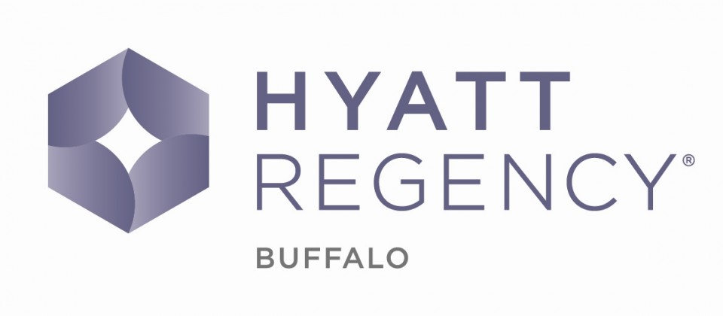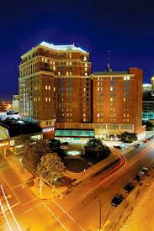

**Hotel Location:**

[Two Fountain Plaza](https://buffalo.regency.hyatt.com/en/hotel/our-hotel/map-and-directions.html)

[Buffalo, New York, USA, 14202](https://buffalo.regency.hyatt.com/en/hotel/our-hotel/map-and-directions.html)

[GPS Address: 300 Pearl Street, Buffalo, New York 14202](https://buffalo.regency.hyatt.com/en/hotel/our-hotel/map-and-directions.html)

[(716) 856-1234](https://buffalo.regency.hyatt.com/en/hotel/our-hotel/map-and-directions.html)

**Parking:**

Valet –

$25 a day, which includes guest in and out privileges.

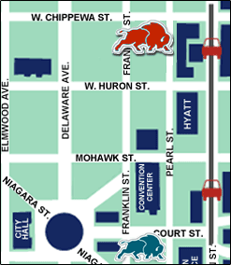Self Parking –

Augspurger Parking Ramp – 362 Pearl St.

(daily max. $7.50, overnight $32.00 - [online](https://secure.bcarparking.com/)),

located adjacent to the hotel across the street

Open lot located directly across the street (daily max. $8.00, overnight $15.00).

[Parking on the street](https://www.buffaloroamapp.com/) is pay by meter or on the Buffalo Roam app. It is free after 5pm and on the weekends.

*Hotel floor plans*

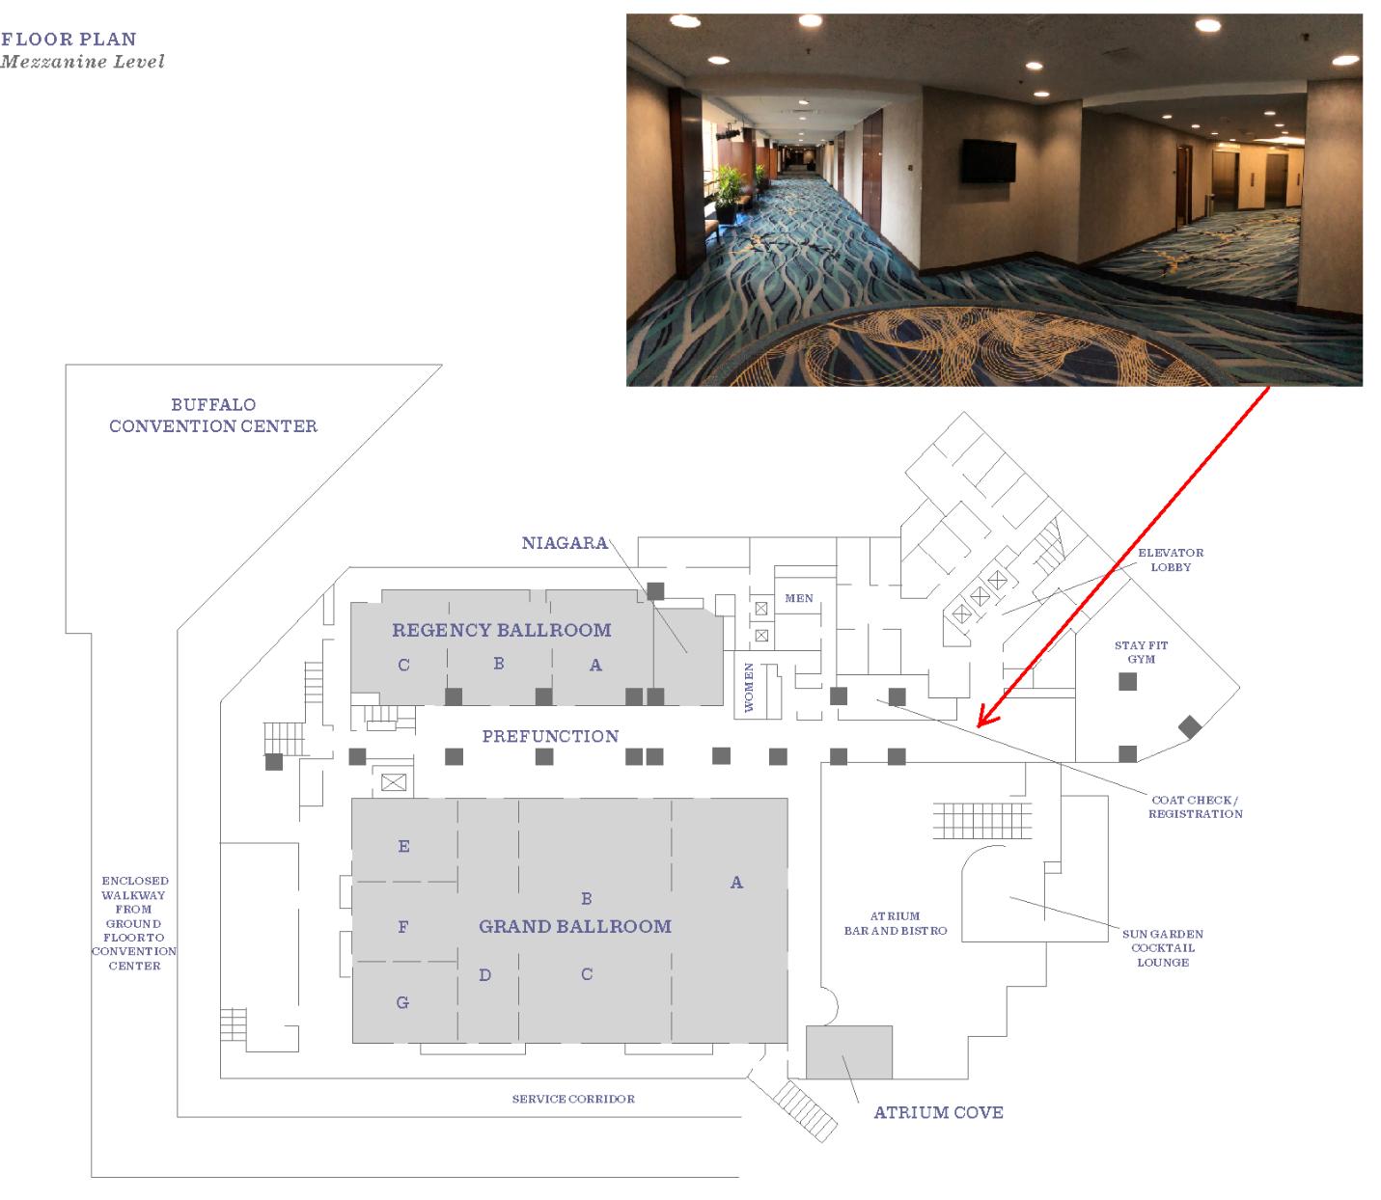

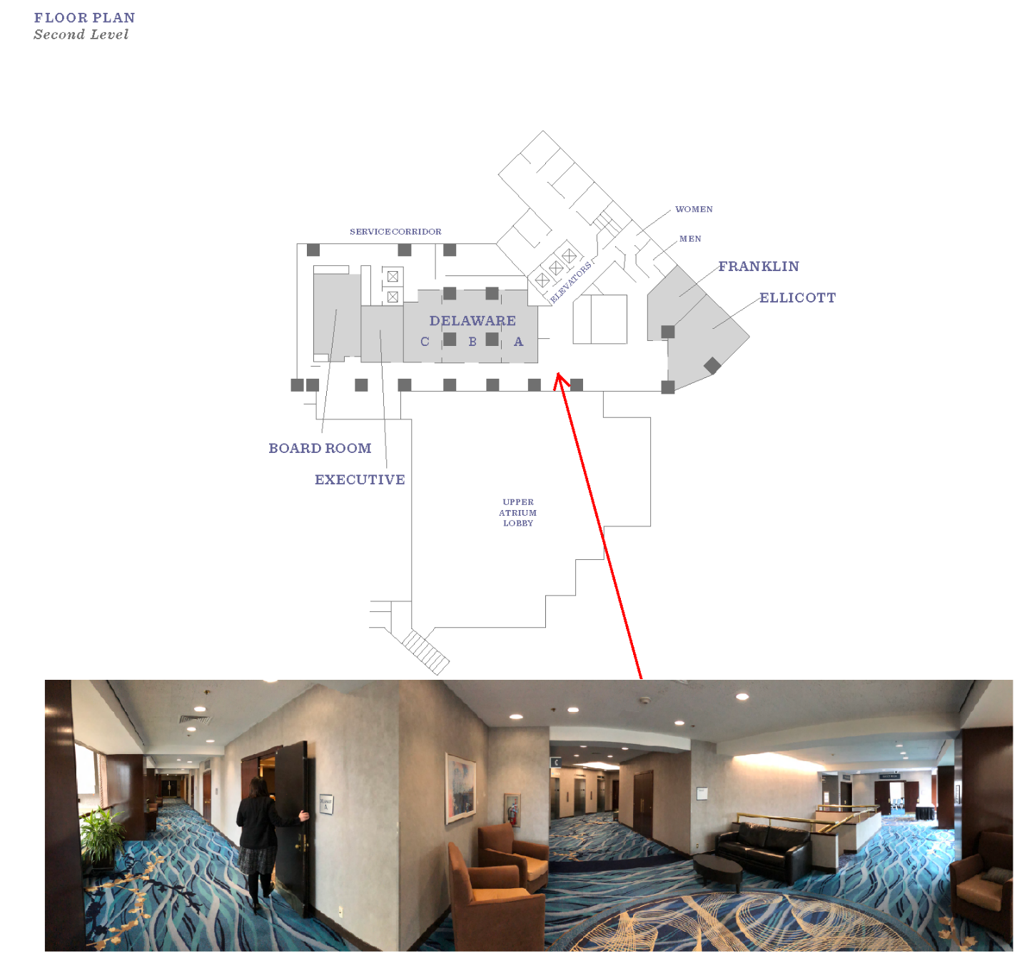

## *Public Transportation*

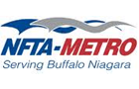

**NFTA-Metro Bus and Rail**  
716-855-7300   
[**metro.nfta.com**](http://metro.nfta.com/) 

**Airport-Downtown Express - Metro Route 204**

This shuttle runs non-stop service between the airport and Buffalo's central business district, making its first stop in front of the Hyatt Regency Buffalo.  One-way fare (in most cases) is $2.50. Service runs weekdays, approximately every 30 minutes, during peak drive time. The stop is located before the "Arrivals" entrance at the airport.

Regular Metro Bus service runs through the heart of the city. It is the most economical way to get to and from the airport. One-way fare is $2. Consult the schedules - [**Route 24 Genesee**](http://metro.nfta.com/Routes/Route.aspx?rt=24), [**Route 27 Wende**](http://metro.nfta.com/Routes/Route.aspx?rt=27), [**Route 68 George Urban**](http://metro.nfta.com/Routes/Route.aspx?rt=68)

Metro Bus and Rail is fully accessible to passengers with special needs.

**Metro Rail**

The train stays above and beneath Main Street, and travels from University at Buffalo South Campus to First Niagra Center. NOTE: Metro Rail provides **complimentary above ground service** from the hotel directly to the First Niagara Center.

Downtown Map (see next page):

<http://metro.nfta.com/Routes/HSBCService.aspx>

**Complimentary above ground service** from the hotel directly to the First Niagara Center.

## *NFTA RAIL MAP*

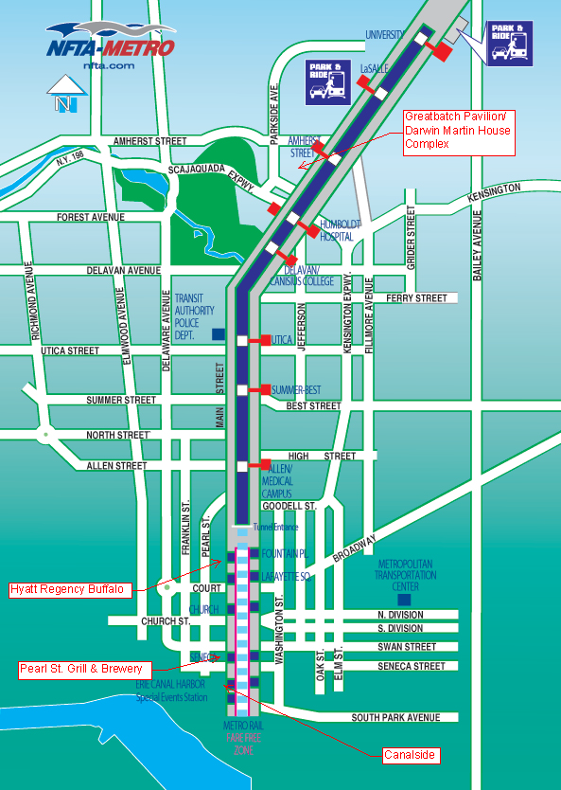

*Rental Cars*



**Alamo**  
(716) 631-2044 | (800) 327-9633

[**www.alamo.com**](https://www.alamo.com/en_US/car-rental/home.html)

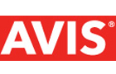

**Avis**  
(716) 632-1809 | (800) 831-2847   
[**www.avis.com**](http://www.avis.com/car-rental/avisHome/home.ac)



**Budget**

(716) 632-4662 | (800) 283-4387   
[**www.budgetbuffalo.com**](http://www.budgetbuffalo.com/)



**Enterprise**

(716) 565-0002 | (800) 736-8222   
[**www.enterprise.com**](http://www.enterprise.com/car_rental/home.do)



**Hertz**

(716) 632-4783 | (800) 654-3131   
[**www.hertz.com**](http://www.hertz.com/)



**National**  
(716) 634-9220 | (800) 227-7368   
[**www.nationalcar.com**](https://www.nationalcar.com/)

*Ridesharing*

If you have arranged for a pickup with a rideshare company (i.e. Uber or Lyft) exit terminal doors closest to carousel 1 in the baggage claim area and follow signs to the designated pick up spots in the hotel shuttle bus lane.



**Lyft**  
[**www.lyft.com**](http://www.lyft.com/)



**Uber**  
[**www.uber.com**](http://www.uber.com/)

## *Shuttles, Vans, and Taxis*

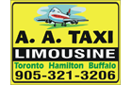

**AA Taxi Transportation Inc**  
(905)321-3206 | (905)735-8294  
[**www.taxiniagara.com**](http://www.taxiniagara.com/)

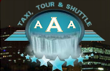

**AAA Taxi Tour & Shuttle**  
(716) 550-0550 | 905-581-3993  
[**www.aaataxitour.com**](http://www.aaataxitour.com/)



**Above the Falls Transportation**  
(716) 957-4192 | (877) 957-4111   
[**www.a-touch-of-class-niagara.com**](http://www.a-touch-of-class-niagara.com/)



**Act One Transportation**  
(716) 908-7405  
[**www.Act1-Transportation.com**](http://www.act1-transportation.com/)

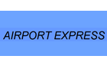

**Airport Express**  
(716) 472-8580 | (800) 604-1570   
[**www.buffaloairportexpress.com**](http://www.buffaloairportexpress.com/)

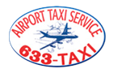

**Airport Taxi**  
(716) 633-8294 | (800) 551-9369   
[**www.buffaloairporttaxi.com**](http://www.buffaloairporttaxi.com/)

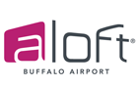

**Aloft Buffalo Airport**  
(716) 626-1800  
[**www.aloftbuffaloairport.com**](http://www.aloftbuffaloairport.com/)



**Bedore Tours**  
(716) 696-3200  
[**www.BedoreTours.com**](http://www.bedoretours.com/)

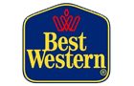

**Best Western Inn**  
(716) 631-8966   
[**www.BestWestern.com/theinnatbuffaloairport**](http://bestwestern.com/theinnatbuffaloairport)



**Buffalo Airport Shuttle**  
(716) 685-2550 | (877) 750-2550   
[**www.buffaloairportshuttle.com**](http://www.buffaloairportshuttle.com/)

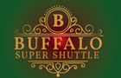

**Buffalo Super Shuttle**  
(716) 498-8700   
[**www.buffalosupershuttle.com**](http://www.buffalosupershuttle.com/)



**Corporate Rent-A-Car**  
716-633-5504  
[**www.corporaterentacar.ca**](http://www.corporaterentacar.ca/)



**EZ Ride Buffalo**  
716-445-7649  
[**www.ezridebuffalo.com**](http://www.ezridebuffalo.com/)



**Gray Line Niagara Falls**  
(716) 285-2113 | (877) 285-2113   
[**www.GrayLineNiagaraFalls.com**](http://www.graylineniagarafalls.com/)



**Liberty Yellow Cab**  
(716) 877-7111 | (877) 783-8900   
[**www.overthefallstours.com**](http://www.overthefallstours.com/)



**Over The Falls Tours**  
(716) 283-8900 | (877) 783-8900   
[**www.overthefallstours.com**](http://www.overthefallstours.com/)



**Wheelz Niagara**  
(289) 296-1966  
[**www.wheelzniagara.com**](http://www.wheelzniagara.com/)



**5-0 Limousine**  
(905) 346-4000

*Emergency contact information*

**In Case of an Emergency, Please dial 911.**

**Hotel Location:**

Two Fountain Plaza

Buffalo, New York, USA, 14202

GPS Address: 300 Pearl Street, Buffalo, New York 14202

(716) 856-1234

**Nearest Hospital:**

Buffalo General Medical Center – Kaleida Health

100 High St.

Buffalo, NY 14203

(716) 859-5600

**Poison Control Center:**

219 Bryant St.

Buffalo, NY 14222

(716) 878-7654

Nearest CVS Pharmacy:

432 Main St.

Buffalo, NY

(716) 856-4530

Nearest Rite Aid:

452 Main St.

Buffalo, NY

(716) 854-4530

**Conference Co-Chair:**

Francis Mahaney

[fmahaney@clarkpatterson.com](mailto:fmahaney@clarkpatterson.com)

716-994-0434

**Conference Co-Chair:**

Jason Havens

[jhavens@clarkpatterson.com](mailto:jhavens@clarkpatterson.com)

*AGENDA*

*This leader training event provides XX PDH units*

**Friday, February 9, 2018**

7:00-7:45 **Registration and Continental Breakfast** (WSBL/ERYMC/WSCL) (*Pre-function Area*)

7:45-8:15 **Welcome** (WSBL/ERYMC) (*Grand B-G*)

Moderator: Don Wittmer, P.E., M.ASCE, Chair, Leader Training Committee

Presenters: Tony Cioffi, P.E., M.ASCE, Region 1 Director

Jason Havens. P.E., M.ASCE, Buffalo Section President

Michael J. Finn, P.E., City Engineer, City of Buffalo DPW

Kristina Swallow, P.E., ENV SP, F.ASCE, ASCE 2018 President

Tom Smith, ENV SP, CAE, F.ASCE, Executive Director

8:15-9:15 **ASCE Live** (WSBL/ERYMC)(*Grand B-G*)

*Learn about the ins and outs of ASCE including the organization, structure, and internal workings*

Moderators: Greg Kuklinski, P.E., M.ASCE, Leader Training Committee

Shawn Kelley, Ph.D., P.E., M.ASCE, Leader Training Committee

Presenters: Nancy Berson, Aff.M.ASCE, Director, Geographic Services

Jennifer Lawrence, Aff.M.ASCE, Senior Manager, Geographic Services

9:15-9:30 **Break** (WSBL/ERYMC/WSCL) (*Pre-function Area*)

9:30-10:30 **Flipping the Script on Networking** (ERYMC/WSCL) (*Grand A, E, F, G*)

Moderator:

Presenter: Jesse Gormley, P.E., ENV SP, M.ASCE, Committee on Younger Members

10:30-12:00 **Region Breakout Session** (WSBL/ERYMC/WSCL)

J*oin others from your Region and learn new names and faces; acquire new skills with a fun filled icebreaker*

*Region Leaders meet with their respective Section/Branch Leaders, Younger Member Leaders and Student Chapter Leaders*

Leaders: Tony Cioffi, P.E., M.ASCE, Region 1 Director (*Regency Ballroom*)

John Casana, P.E., D.WRE, LEED AP, F.ASCE, Region 2 Director (*Grand E-F-G*)

Chuck Black, P.E., M.ASCE, Region 4 Director (*Grand A*)

Peter Moore, P.E., F.ASCE, Region 5 Director (*Delaware*)

12:00-12:40 **Networking Lunch** (WSBL/ERYMC/WSCL) (*Grand B-G*)

Moderator: Peter Moore, P.E., F.ASCE, Region 5 Director

12:40-12:55 **Society Speaker** (WSBL/ERYMC/WSCL) (*Grand B-G*)

Moderator:

Presenter: Robin Kemper, P.E., LEED AP, F.SEI, F.ASCE, 2018 ASCE President-elect

1:15-2:45 **CYM Town Hall and Roundtables** (ERYMC) (*Grand E-G*)

*Roundtable topics include: Fundraising, Government Affairs, Professional Development, University Outreach and Job Fair, K-12 and Community Outreach, Social Media and Marketing, Social and Networking Events, Increasing Membership, and Board Recruitment and Retention*

Moderator:

Presenters: Jesse Gormley, P.E., ENV SP, M.ASCE, Committee on Younger Members

2:30-2:45 **ERYMC Group Photo**

*Announcement will be made prior on location*

2:45-3:00 **Networking Break** (WSBL/ERYMC/WSCL) (*Pre-function area*)

3:05-4:00 **Society Leaders Q&A** (WSBL/ERYMC) (*Regency Ballroom*)

Moderator: John Casana, P.E., F.ASCE, Region 2 Director

Leaders: Kristina Swallow, P.E., ENV SP, F.ASCE, ASCE 2018 President

Robin Kemper, P.E., LEED AP, F.SEI, F.ASCE, 2018 President-elect

Tom Smith, ENV SP, CAE, F.ASCE, Executive Director

4:00-4:15 **“The ASCE Adventure” Awards Presentations** (WSBL/ERYMC) (*Regency Ballroom*)

Presenters: Nancy Berson, Aff.M.ASCE, Director, Geographic Services

Shawn Kelley, P.E., Ph.D., M.ASCE, Leader Training Committee

4:15-5:15 **Growing a Region: The Future of Buffalo’s Waterfront** (ERYMC) (*Grand E-G*) **X.X PDH**

Moderator: Francis Mahaney, E.I.T., A.M.ASCE, Buffalo Section President-elect

Presenters: Steven P. Ranalli, P.E., Vice President of Waterfront Development, Empire State Development, Erie Canal Harbor Development Corporation

6:00-10:00 **Joint** **Social** (WSBL/ERYMC/WSCL) (*Pearl Street Grill / Canalside*)

*Ticketed event. Appetizers and drink tickets provided at Pearl Street Grill. Both locations accessible by public transit and/or walking. Event details:*

6:00-8:00 Social @ Pearl Street Grill

7:00-10:00 Ice Skating @ Canalside

9:00-10:00 Curling @ Canalside

**Saturday, February 10, 2018**

7:30-8:00 **Networking Breakfast** (WSBL/ERYMC/WSCL) (*Grand B-G*)

*Meet new friends and learn their stories; swap business cards; learn what classes students enjoy and why they want to be Civil Engineers*

Moderator:

8:00-8:30 **Coffee with the 2019 President-Elect Nominees** (WSBL/ERYMC/WSCL) (*Grand B-G*)

Moderator:

8:30-9:15 **Managing the Disruption of the Civil Engineering Profession**(WSBL/ERYMC/WSCL)

(*Grand B-G*)

Moderator: Chuck Black, P.E., M.ASCE, Region 4 Director

Presenter: Maria Lehman, P.E., F.ASCE, Director of Strategic Initiatives,

Ecology & Environment, Inc.

9:20-10:15 **The good, the bad, and where we should take MWBE policy** (ERYMC) (*Grand E-G*) **X.X PDH**

Moderator: Jason Havens. P.E., M.ASCE, Buffalo Section President

Presenters: Rosanne Frandina, P.E., L.S., Frandina Engineering And Land Surveying, P.C.

Stacy M. Kubit, P.E., WSP

10:15-10:30**Networking Break** (WSBL/ERYMC/WSCL) (*Pre-function area*)

10:30-12:10 **Business Meeting** (ERYMC) (*Grand E-G*)

Chair: Melissa Burns, P.E., M.ASCE

12:15-12:35 **Leadership** **Lunch** (WSBL/ERYMC/WSCL) (*Grand B-G*)

*Enjoy lunch with new friends and discuss the events of the weekend; share new ideas and actions you learned from the weekend sessions*

Moderator:

12:35-1:25 **ASCE Industry Leaders Council Keynote: *“XXXXX”*** (WSBL/ERYMC/WSCL) (*Grand B-G*) **1.0 PDH**

*Learn from those who have made leading others a career goal and found success*

Moderator: Don Wittmer, P.E., M.ASCE Chair, Leader Training Committee

Presenter: Nicholas M. DeNichilo, P.E., F.ASCE, President and CEO, Mott MacDonald North America

1:30-2:30 **Should we Raise the Bar? - Insights from other Industries** (ERYMC) (Grand B-G) **X.X PDH**

Moderators: Jason Havens. P.E., M.ASCE, Buffalo Section President

Francis Mahaney, E.I.T., A.M.ASCE, Buffalo Section President-elect

Panelists: Kelly Dooley, P.E., M.ASCE, Director, Raise the Bar

Bethany Mazur, J.D., Director of Alumni and Constituent Engagement - University at Buffalo

Jason Lang, M.BA, CPA, Defense Contract Audit Agency

Dr. John McGrath, MD, Interventional Radiologist, John R. Oishei Children’s Hospital and Gates Vascular Institute

3:00 **Adjourn** (WSBL) (Regency Ballroom)

5:00 **Awards Dinner** (WSBL/ERYMC) (*Greatbatch Pavilion*)

*Ticketed event. Dress code is business casual. Bus pickup will be on West Huron St, directly outside the hotel entrance. Buses will begin boarding at 4:30 PM.*

Eleanor and Wilson Greatbatch Pavilion

143 Jewett Parkway

Buffalo, NY 14214

INSERT JOINT MATRIX HERE

*Special events*

*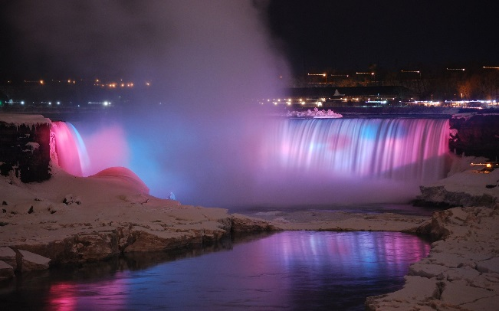***Pre-Game**

**Date:** Thursday, Feb. 8th

**Time:** 5 – 10 p.m.

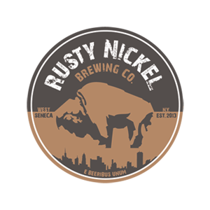**Transportation:** Provided

**Pick Up:** Hyatt Regency Buffalo, West Huron St.

**Location:** Niagara Falls & RNBC

**Cost:** $25.00

Description:

It’s #tbt, so take a ride with us to view what was once a wonder of the world, Niagara Falls. Stay at the Falls and watch them light up at 10 p.m. or come back to Buffalo with us earlier to enjoy a craft beer on us at Rusty Nickel Brewing Co. (Owned and made by one of the Section’s own). Make friends to enjoy the rest of the conference with and put a team together for table games and bring them with you for curling on Friday.

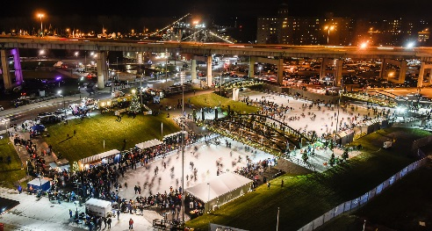

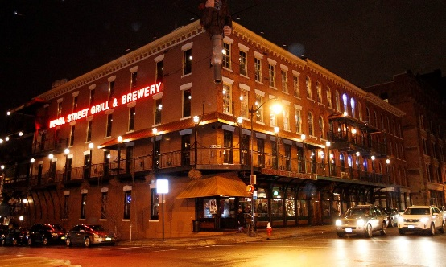

**Networking Social**

**Date:** Friday, Feb. 9th

**Time:** 6 – 10 p.m.

**Transportation:** Not Provided

Recommend using the NFTA light rail

by walking right out of the hotel on W. Huron St. and then left at Main St. to the stop on the corner OR walking left outside the hotel and straight down Pearl St.

**Location:** Pearl St. Grill & Brewery

**Cost:** FREE

**Description:**

Winter is here. So let’s do some wintery things - Eat and drink in a cozily rustic restaurant/brewery, ice skating – definitely, ice biking- maybe, curling – you’ve got to try this. I hope you brought your team from Thursday. If not, there will be plenty of socializing and feel free to go out on the town down Chippewa St.. Take the light rail to see the bright theatre district. And if you’re so bold, take it a few stops farther and walk or grab a rideshare over to Delaware park to see that winter wonderland. Heck, maybe even venture as far as Duff’s near UB (University AT Buffalo).

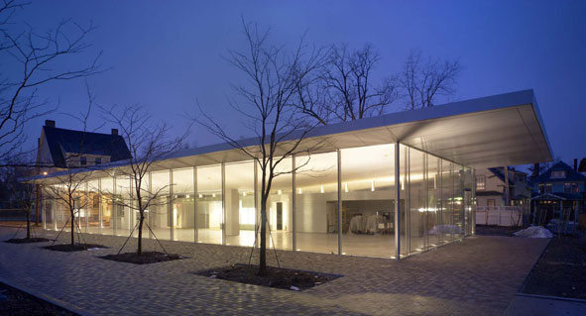**Awards Dinner**

**Date:** Saturday, Feb. 10th

**Time:** 5 – 8 p.m.

**Transportation:** Provided

**Pick Up:** Hyatt Regency Buffalo, West Huron St.

**Location:** Greatbatch Pavilion / Darwin Martin House Complex

**Cost:** $50 – Dinner & Tour

**Description:**

Let’s wrap this all up with an elegant sit down dinner at the Greatbatch Pavilion situated on the Frank Lloyd Wright’s Darwin Martin House Complex. If you choose, you can tour what is considered one of Wright’s finest Prairie Houses, the Martin House prior to the dinner. There’s limited seating, so make sure to register for this one early. We’ll pick you up and drop you back off at the hotel so you can either fly to warmer climates or hang around, we won’t mind. We’re the city of good neighbors after all.

*ASCE BIOS*

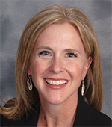Since 2012, Kristina has been with the City of Las Vegas leading a team of engineers responsible for delivering public works projects and planning the sanitary sewer collection system. She negotiates design and construction contracts, reviews progress of the work, coordinates with public and private sector stakeholders, and responds to external comments or questions. Additionally, she advises on bicycle and pedestrian-related infrastructure, representing the City at the Nevada Legislature, participating in public meetings and guiding public outreach policy.

As ASCE's Congressional Fellow in 2009, Kristina landed a position in the Office of Senator Tom Udall as his lead on transportation policy. During that time, she worked on the Federal Aviation Administration reauthorization bill and development and passage of the MAP-21 surface transportation authorization bill.

Kristina has been active in ASCE since 1995, serving on various society-level committees, such as Program and Finance, the Committees on Education, Diversity and Younger Members. She served as the Society’s appointed Governor on the Utility Engineering and Surveying Institute until her election as ASCE’s 2018 President.

In addition to her professional activities, Kristina is active in her community. She has served in leadership roles with the Junior League of Las Vegas, Southern Nevada Bicycle Coalition, Engineers Without Borders, and on the Advisory Board to the University of Nevada Department of Civil and Environmental Engineering and Construction.

Kristina earned her bachelor’s degree in civil engineering from the University of Arizona in 1994 and a master’s degree in civil and environmental engineering from the University of Nevada in 2004.

A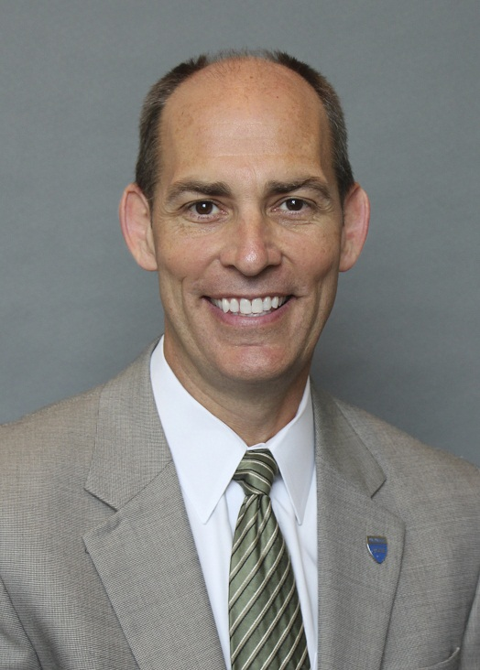 dedicated member of the American Society of Civil Engineers for more than 25 years and a civil engineer by training, Tom Smith served as the association’s deputy executive director and general counsel before becoming the executive director in January 2015. Established in 1852, ASCE is the oldest national professional engineering society. With a membership of over 150,000 and an annual operating budget of over $65 million, the Society is dedicated to advancing the art, science and profession of engineering for the betterment of humanity. Smith is responsible for the day-to-day management of the Society. He provides executive leadership to a staff of 280 and an active volunteer workforce of over 7,500, facilitating ASCE's tradition of supplying high-quality and high-value products and services to its members and other customers worldwide.

*SPEAKER BIOS*

Bethany Mazur, Director of

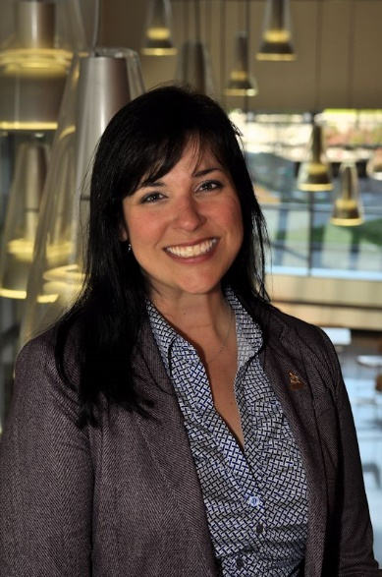Bethany Mazur is the Director of Alumni and Constituent Engagement at UB's School of Engineering and Applied Sciences. Boasting over 33,000 alumni in all 50 states and over 70 countries, it's the largest engineering school in New York State. In her current position she works alongside the school's faculty and staff to engage alumni and friends for the benefit of the school, its students, its alumni, and our community.

Bethany earned both a BS in economics and a JD (law) from the University at Buffalo. After graduation she joined Mura & Storm, PLLC as an associate attorney where she practiced insurance law and contributed to the firm's annual Insurance Coverage Seminar. She specialized in No-Fault law and arbitration work.

Throughout her career Bethany also spent several years working alongside Kevin Gaughan, Esq. as Policy Director of "The Cost," an effort to identify and quantify the cost of WNY having more elected officials per capita, at the time, than anywhere else in the country. That work eventually led to the "Let People Decide" effort which empowered several successful citizen-led efforts to reform and reduce the size of government in Western New York. She lives near the Big Blue Water Tower with her husband, one-year-old daughter, and two dogs. She is a board member of the Mason's Mission Foundation and is active in the local Christian community. She has also served on the boards of B Team Buffalo and the Cystic Fibrosis Foundation.

Jason Lang has worked at the Department of Defense for the Defense Contract Audit Agency (DCAA) for over 12 years. A graduate of the University at Buffalo with a BS in Business Administration (‘05, Accounting/Finance concentrations) and a Masters of Business Administration (‘11), Jason is also a Certified Public Accountant registered in the Commonwealth of Virginia.

In his career at the DCAA, Jason has performed and assisted in audits overseeing billions of dollars of DoD procurements, resulting in tens of millions of dollars in cost savings to the Government. His current roles involve audit quality control and assistance with external oversight reviews.

Jack McGrath

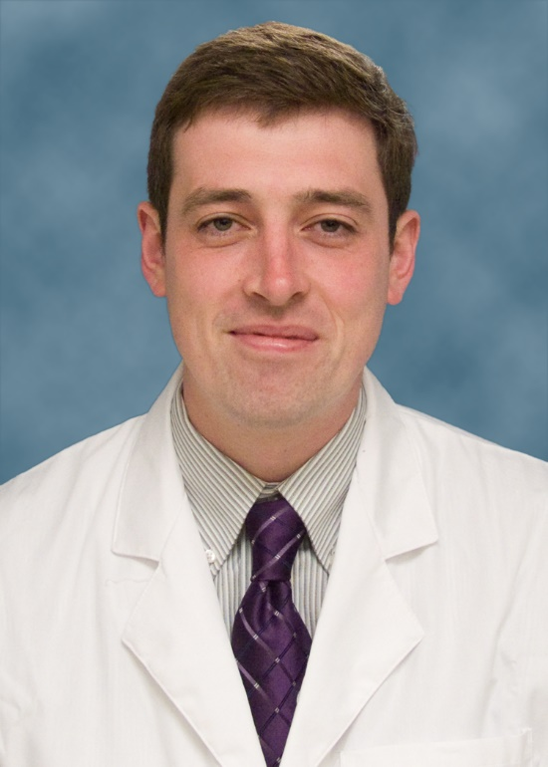Jack McGrath is an Interventional Radiologist practicing at John R. Oishei Children’s Hospital and Gates Vascular Institute in Buffalo, NY, where he focuses on performing minimally invasive, image-guided procedures. He returned to Buffalo in 2015 after completing an Interventional Radiology fellowship at Brigham and Women’s Hospital in Boston, MA, and finished his residency training in Diagnostic and Interventional Radiology at the University of Rochester/Strong Memorial Hospital.

Jack spent 8 wonderful years at the State University of New York at Buffalo, graduating with a BS in biochemistry in 2005 and MD in 2009. He lives in the Elmwood Village with his wife, Sarah, also a physician, and is a proud UB basketball season ticket

Steven Ranalli

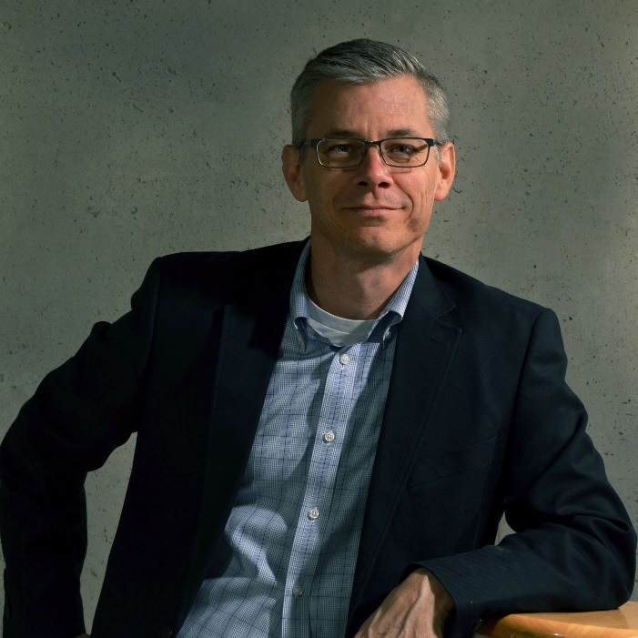Steven Ranalli is a professional engineer with experience in engineering, urban planning, design, and economic development.  Mr. Ranalli is currently the Vice President of Waterfront Development with the Erie Canal Harbor Development Corporation and manages the planning, design and construction projects within the Corporation’s 450 acres of waterfront property.  Major projects include the reconstruction of the historically aligned canals at Canalside, replicating the western terminus of the Erie Canal; the Explore and More Children’s Museum; and the Ohio Street reconstruction project, a major waterfront arterial linking the City’s inner and outer harbors.

Mr. Ranalli is currently managing the redevelopment of the South Aud Block at Canalside, as well as the master plan of the First Buffalo River Marina, the rehabilitation of Terminal B, and the State’s $20 million Buffalo Billion investment, all on the Outer Harbor.  In addition, Mr. Ranalli leads the Canalside Design Review Committee, Cultural Advisory Board, and is a member of New York State’s Smart Growth Review panel.  Mr. Ranalli is a graduate of the University at Buffalo, a Western New York native, and resides with his wife and three children in East Aurora.

Jason Havens

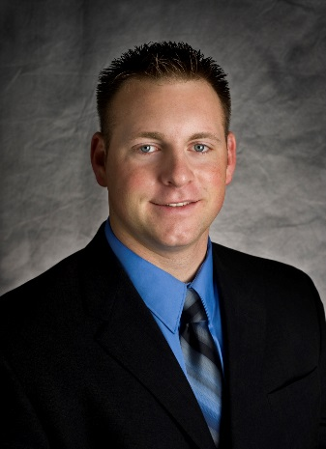Jason Havens is a Project Manager of civil and transportation projects at Clark Patterson Lee where he has thirteen years of design and construction experience. He has designed and lead a wide range of engineering projects that span multiple disciplines including site design, storm and sanitary sewer systems, water systems, park master plans, traffic studies, and bridge and highway designs. In addition to his design experience, Jason also provides construction administration and inspection for local municipalities for site, bridge and highway construction projects. Mr. Havens has worked for numerous municipal clients, as well as the New York State Department of Transportation, Georgia Department of Transportation and State University of New York.

Jason graduated from the UB in 2005 with a B.S. in Civil Engineering and immediately joined Clark Patterson Lee as part of the transportation design team. He has been an instructor at the University at Buffalo (UB) for nine (9) years where he teaches civil engineering design with MicroStation and InRoads. Jason earned his Professional Engineering license for New York State in 2011, and has completed reciprocity of licensure in Georgia, North Carolina and South Carolina.

He is an inspiring and enthusiastic supporter of the civil engineering profession. Serves as the acting ASCE Buffalo Section President and was also the Section President in 2012. He feels strongly that mentoring is not an option for engineers but rather an obligation! As such, he’s volunteered for programs like Future Cities, as a mentor for young engineers at Clark Patterson Lee, an ASCE Student Practitioner Advisor at UB as well as the Concrete Canoe Team Mentor for over a decade. He was recently awarded the University at Buffalo Mentor of the Year.

Outside the office, Jason is an active member of the community, seeking ways to give back through education and outreach and is an entrepreneur in the craft beer industry. He is a proud recipient of awards with ASCE including Outstanding Practitioner Advisor, New Faces of Engineering, the Edmund Friedman Young Engineer for Professional Achievement and the Buffalo Business First, 30 Under Thirty Award for business.

PHARMACIST, KELLY DOOLEY, DAVE PETERSON, STACY KUBIT